Map_Algebra_Vienna

Bandwidth Operator: SCV

**Grid Size Selection**

Experiment: February – January

GridSize : 400*400

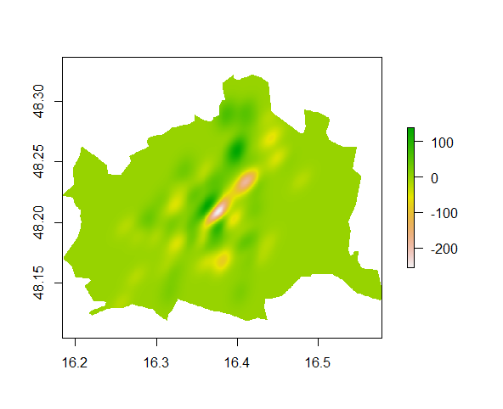

GridSize : 200*200

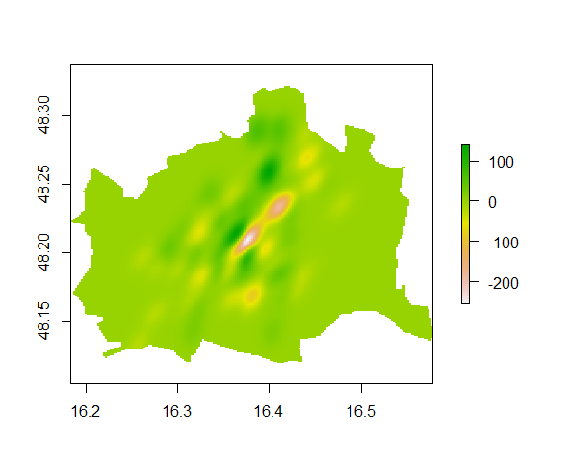

GridSize : 100*100

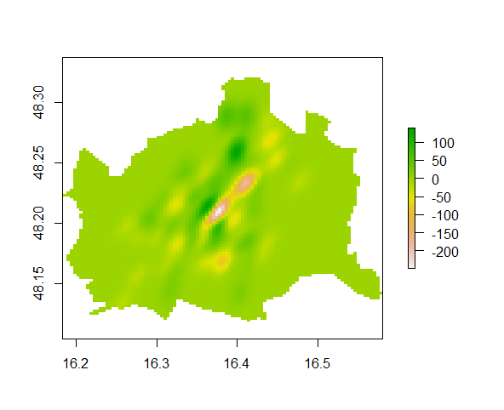

GridSize : 50*50

